C O N T I N U O U S M E M B E R C E R T I F I C A T E

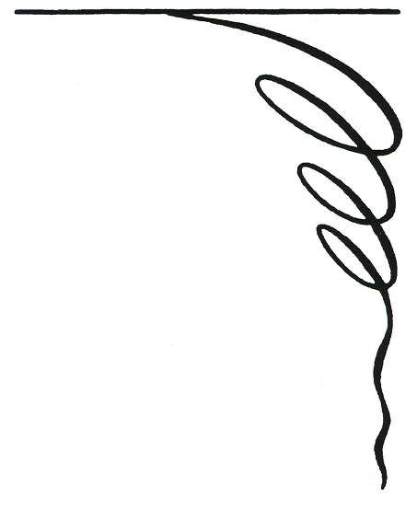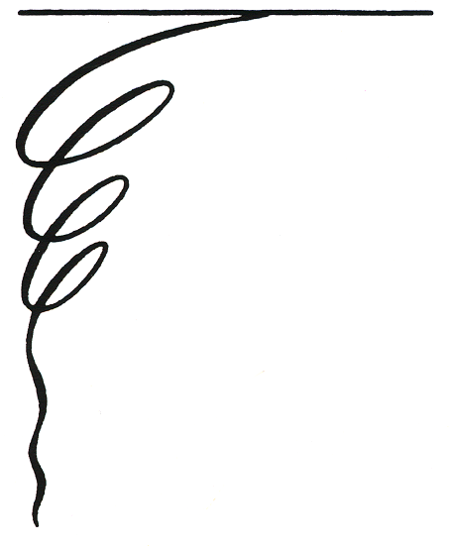

BE IT KNOWN THAT

PROPER ATTESTATION HAS BEEN PROVIDED TO THE EFFECT THAT

HAS BEEN A MEMBER IN GOOD STANDING
OF THE AMERICAN LEGION CONTINUOUSLY
FOR THE PERIOD OF


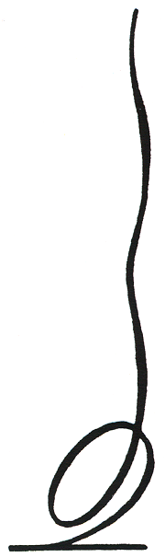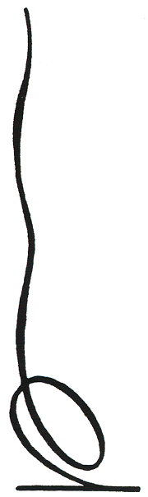

AND BE IT FURTHER KNOWN THAT SUCH
RECORD OF CONSISTENT LOYALTY TO
THE AMERICAN LEGION MERITS THE
HONOR OF BEING CITED AS AN OUT-
STANDING CONTRIBUTOR TO THE
ACCOMPLISHMENT OF THE PROGRAMS
OF THE AMERICAN LEGION.

,

ATTEST:___________________________________ ______________________________________
POST ADJUTANT POST COMMANDER

